

eHealth Network

**GUIDELINE**

on

the electronic exchange of health data under   
Cross-Border Directive 2011/24/EU

**Medical images and medical imaging reports**

Release 1

|  |
| --- |
| **The eHealth Network is a voluntary network, set up under article 14 of Directive 2011/24/EU. It provides a platform of Member States' competent authorities dealing with eHealth.** |
|  |
|  |

-Keep this page free-

**Table of Contents**

1 USE CASE DESCRIPTION 5

1.1 Medical images and medical imaging reports 5

1.1.1 Use case 1: Request and retrieve of medical images and medical image reports by a health professional treating a patient 5

1.1.2 Use case 2: Request and retrieve of medical images and medical image reports by a patient 8

1.1.3 Use case 3: Provision of medical images to a health professional treating a patient 9

1.1.4 Use case 4: Ordering of medical image evaluation and retrieval of a medical imaging report 9

2 GUIDELINES FOR MEDICAL IMAGES AND MEDICAL IMAGING REPORTS 9

2.1 Chapter I - General Considerations 9

2.1.1 Article 1: Objectives and scope 9

2.1.2 Article 2: Definitions & Abbreviations 10

2.1.3 Article 3: Intended use 13

2.2 Chapter II - Legal and Regulatory Considerations 14

2.2.1 Article 4: Data protection 14

2.2.2 Article 5: Identification, authentication and authorisation 14

2.2.3 Article 6: Patient safety 14

2.3 Chapter III - Organisational and Policy Considerations 15

2.3.1 Article 7: Enablers for implementation 15

2.3.2 Article 8: Quality standards and validation 15

2.3.3 Article 9: Education, training and awareness 15

2.4 Chapter IV - Semantic Considerations 15

2.4.1 Article 10: Data 15

2.4.2 Article 11: Terminology 17

2.4.3 Article 12: Controlled Lists (Value set Catalogues) 17

2.5 Chapter V - Technical Considerations 17

2.5.1 Article 13: Technical requirements 17

2.5.2 Article 14: Security 18

2.5.3 Article 15: Testing and audit 18

3 SUPPORTING INFORMATION 18

3.1 Chapter I - General Considerations 18

3.1.1 Article 1: Objectives and scope 19

3.1.2 Article 2: Definitions 19

3.1.3 Article 3: Concept and intended use 19

3.2 Chapter II - Legal and Regulatory Considerations 19

3.2.1 Article 4: Data protection 19

3.2.2 Article 5: Authorisation, authentication and identification 19

3.2.3 Article 6: Patient safety 19

3.3 Chapter III - Organisational and Policy Considerations 19

3.3.1 Article 7: Enablers for implementation 19

3.3.2 Article 8: Quality standards and validation 21

3.3.3 Article 9: Education, training and awareness 21

3.4 Chapter IV - Semantic Considerations 21

3.4.1 Article 10: Data 21

3.4.2 Article 11: Terminology 22

3.4.3 Article 12: Controlled Lists (Valueset Catalogue) 23

3.5 Chapter V - Technical Considerations 23

3.5.1 Article 13: Technical requirements 23

3.5.2 Article 14: Security 25

3.5.3 Article 15: Testing and audit 25

4 DATA SETS 25

4.1 Medical imaging report data set 26

4.1.1 Medical imaging report header 26

4.1.2 Medical imaging report body 31

4.2 Imaging study DICOM Metadata data set 39

5 REFERENCES AND EXAMPLES 41

# USE CASE DESCRIPTION

## Medical images and medical imaging reports

This use case represents a high level of consensus on what constitutes European eHealth services, as this use case contributes to the application of patients' rights in cross-border healthcare per Directive 2011/24/EU of 9 March 2011. Medical imaging and reports are explicitly noted in Paragraph 11 d ~~c~~ of EC Recommendation of 6.2.2019 on a European Electronic Health Record exchange format. Four use cases are proposed, of which use case 1 is in scope for the first version of this Guideline.

### Use case 1: Request and retrieve of medical images and medical image reports by a health professional treating a patient

Priority: 1

|  |  |
| --- | --- |
| **Title** | **Drafts for the guideline** |
| Purpose | Imaging studies and reports are made available to a requesting health professional:   * When a previously performed imaging study or report is needed to support clinical decision making. * In case of emergency or to support consultation or for continuity of care. |
| Relevance | The availability of previously performed imaging studies and reports may help to:   * Prevent unnecessary harm to the patient because of medical irradiation * Provide better support for health professional in care-related decision making * Avoid unnecessary imaging procedures and duplication, gaining time and reducing costs * Provide a possibility to compare results |
| Domain | Producers: specialised medicine, no specialties are excluded. Medical images are commonly produced by specialties such as radiology,  nuclear medicine, cardiology, medical photography, pathology, neurology (ultrasound), internal medicine, gynaecology, obstetrics, dental medicine, urology.  Consumers: any healthcare provider or a patient.  The guideline intends to extend the use of medical imaging to a broader context. |
| Scale | Cross-border, national/regional, between organizations.  The focus is on the cross-border exchange, but the guideline may also be used in other contexts. |
| Context | 1. The availability of both medical images and medical image reports is relevant for the continuity of care. Imaging studies and corresponding reports are often presented together, using a unique ID that links them together. End users should be able to select access to either the image study or the accompanying imaging report, or both. 2. A list of available imaging studies may contain many list items (sometimes hundreds). In order to quickly access the desired information for the task at hand, the end user must be able to select and combine different search parameters. This requires a predefined set of metadata elements that can be used for grouping, sorting and filtering the list of available information. 3. These metadata elements should enable different methods for searching. |
| Information | These guidelines provide information specifications on the following:   * Imaging Study * Imaging Report * Metadata on imaging studies and reports used for search and retrieval   The metadata enable the creation and presentation of a list of available imaging studies and reports, sortable on time, purpose, body part, modality, provenance or other (combinations of) attributes. They are also used to connect/link individual imaging studies to their accompanying imaging reports. |
| Participants | 1. Health professional(s) in patient's country of origin/affiliation (country A) 2. Health professional in the country of visit/treatment (country B) 3. Citizen/Patient |
| Preconditions | There should be sufficient bandwidth for transmitting the images across the network.  Metadata enabling the presentation, filtering, grouping and ordering of medical images and medical imaging reports should be available according to the requirements presented in Section 2.4.1.  Imaging studies and imaging reports should share common identifiers when they are associated. |
| Functional process steps | 1. The Patient consults a Health Professional in the country of treatment (Country B). 2. The Health Professional (in Country B) is identified, authenticated and authorised. 3. The Patient is identified (in Country B) and the patient identity is confirmed by the country of affiliation (Country A). 4. The Health Professional (in Country B) provides information to the patient on how personal health data in the imaging studies and reports will be collected and processed in Country B. 5. Health professional in country B queries country A for a list of imaging studies and imaging reports of that patient based on the query parameters (for example time interval, study type(s), body part(s), and procedure code(s)). 6. Country A provides a list of the available imaging studies and/or reports to Country B. 7. The Health Professional selects (including: filtering, ordering, grouping) and requests the relevant imaging studies and/or reports from Country A. 8. Country A provides the requested imaging studies and/or reports to Country B. In case there are multiple versions of studies/reports, the latest versions are provided. 9. The Health Professional (in Country B) is presented with the requested imaging studies and/or reports through a user interface provided by a local information system, a dedicated viewer, a portal or an alternative technical solution. The Health Professional may also be enabled to download the requested imaging studies and/or reports to the system used locally for later use if allowed by the national law and relevant data protection arrangements. 10. The Health Professional (in Country B) uses the imaging studies and/or reports to provide healthcare service.   Depending on national law in Country B, the retrieved information might be stored, e.g. for the purposes of keeping track of health data used for any clinical decisions. The storage time is regulated in this case by national law in Country B. |

**Table 1: medical images and medical imaging reports Result Report use case description**

### Use case 2: Request and retrieve of medical images and medical image reports by a patient

To be decided upon in a later version of the Guideline.

Priority: 2

### Use case 3: Provision of medical images to a health professional treating a patient

A specific set of medical images (and possibly medical imaging reports) are sent from Country A to Country B to provide aid in treating a patient (notably in second opinion or emergency scenarios). More information about the use case is available in D5.4 Chapter 5 of the X-eHealth. A notification about the relevant information is pushed to Country B, followed by a request (pull) of the indicated information.

To be decided upon in a later version of the Guideline.

Priority: 3

### Use case 4: Ordering of medical image evaluation and retrieval of a medical imaging report

Second opinion, consultation for rare diseases.

To be decided upon in a later version of the Guideline.

Priority: 3

# GUIDELINES FORMEDICAL IMAGES AND MEDICAL IMAGING REPORTS

The Member States in the eHealth Network have adopted these supplementary clauses to the eHealth Network General Guidelines for the electronic exchange of health data under Cross-Border Directive 2011/24/EU to support the exchange of medical images and medical imaging reports data. These guidelines add use case specific guidelines and do supplement the eHealth Network General Guidelines.

## Chapter I - General Considerations

### Article 1: Objectives and scope

Medical images and medical imaging reports cover a wide domain of techniques and procedures to visualise the internal structures or functioning of the body, that normally cannot be seen from the outside. It provides insight into the location, size, structure, density and movement of anatomical and other structures. Imaging techniques are used in all stages of the healthcare process, from prevention, diagnosis, intervention to follow-up. They enable health professionals (increasingly assisted by image processing algorithms) to find the right diagnosis, guide therapeutic decisions and aid in surgical procedures.

These guidelines are addressed to the Member States of the European Union and apply to the implementation of exchange of interoperable medical images and medical imaging reports cross-border exchange in order to support safe and efficient provisioning of care services in another Member state. These guidelines could also serve as a guiding principle for the national development and the implementation of medical images and medical imaging reports exchange.

Systems implemented using these guidelines could reduce duplication of medical images. This means patients do not have to go through repetitive testing and imaging procedures such as MRIs and CT scans. The availability of previously taken medical images and related imaging reports could improve treatment outcomes. The availability of medical images and imaging reports could also be useful in consultations between health professionals regarding their patients, especially in case of difficult situations or in cross-border context.

In scope:

* Use case of priority 1: Images and imaging reports produced in Country A (country of affiliation) and fetched by a health professional in Country B (country of treatment).
* All types of DICOM objects (radiological images, light photography, ultrasound images, endoscopy videos, microscopic slides, measurements such as electrocardiograms, a series of blood pressure measurements et cetera) needed in Country B and made available by the health professional from Country A.
* Imaging reports.

Out of scope for 2023:

* Other use cases (priority 2-3) e.g. images taken in Country B and sent back to Country A, patient access to Imaging Studies and Reports)
* Radiation dose management
* Hanging protocols management
* Ordering and Workflow
* Editing and Annotation on existing image studies
* Translation of texts within DICOM objects
* Reimbursement of medical services

### Article 2: Definitions & Abbreviations

For the purpose of these guidelines, the definitions included in the Directive 2011/24/EU, in the eHealth Network General Guidelines, and the following definitions shall apply:

**Definitions:**

| **Term** | **Definition** |
| --- | --- |
| Accession number | Identifier of an imaging study assignment. Links a DICOM imaging study to an imaging report. This link is only unique locally, not nationally or globally. For international use a globally unique ID is needed. Occasionally, one imaging study can result in multiple imaging reports. |
| Acquisition date | Date and time when the imaging study (CT, MNRI, US etc.) was performed. |
| Health professional | The Health professional is the qualified person providing care. |
| Imaging report | An imaging report reflects the observations and interpretations of one or more image studies. It usually contains elements such as the reason why the study is requested, relevant contextual medical information, the used modality and its settings, procedures and body localisations that were used, a description of the observations and findings, exposure information, conclusion and advice. |
| Imaging study | An imaging study comprises a set of objects, including images and other objects, that were made for a specific purpose and usually in relation to a specific question from a healthcare provider. |
| Instance | An instance is the smallest component of the DICOM world, representing a persistent storable object, such as a slice of a CT scan or 3D image consisting of many ‘layers’. Each DICOM instance is a composite object containing the image itself, and the necessary metadata (header) information to describe that instance. |
| Medical imaging | Medical imaging refers to technologies and processes used to create images of the human body for clinical analysis, diagnostic and treatment purposes. It encompasses many different purposes, techniques, specialties and procedures. |
| Metadata | Metadata are information parameters that provide contextual information about the actual information within a document (or other information container). Examples are: date of event and/or publication, size in bytes, technical format, template, standard version, document version, author specialty, functional category et cetera |
| Modality | A DICOM modality represents either the equipment that was used to acquire the data (e.g., CT, MRI, X-ray), or describes the type of data (e.g., RadioTherapy object, Secondary Capture). The DICOM Modality is one of the contextual structured information elements (tag 0008,0060) that describes the combination of hardware (machine, device) and accompanying software used in the creation of a series and instances. |
| Patient | The Patient is the person receiving care. (Q Esther: move to general guideline?) |
| Radlex | Lexicon of radiological Information |
| Series | Each DICOM study contains one or more series. A series is defined as a set of one or more DICOM instances that were generated by the one equipment (modality) at one encounter/session with the patient. A single imaging study can contain different types of modalities in a series, for example, within a single study, there may be a PET series, a CT series, and a plain X-ray image. |

**Abbreviations:**

| **Abbreviation** | **Meaning** |
| --- | --- |
| CT | Computed Tomography |
| DICOM | Digital Imaging and Communications in Medicine (DICOM) is the global standard for medical images developed by [American College of Radiology](https://en.wikipedia.org/wiki/American_College_of_Radiology) (ACR) and [National Electrical Manufacturers Association](https://en.wikipedia.org/wiki/National_Electrical_Manufacturers_Association) (NEMA). It offers a standardised representation of images, together with related contextual information. It encompasses a uniform methodology for the capture, storage and distribution of medical images anywhere in the world. |
| ECG | Electrocardiogram |
| EEG | Electroencephalogram |
| EEHRxF | European eHealth Record Exchange Format |
| EHR | Electronic Health record |
| EIS | Enterprise Image Server |
| EMG | Electromyography |
| EMIR | Enterprise Medical Imaging Repository |
| ESR | European Society of Radiology |
| EUG | Electro-urogram |
| FHIR | Fast Healthcare Interoperability Resources |
| HIS | Hospital Information System. |
| ICD-10 | International Statistical Classification of Diseases and Related Health Problems 10th Revision |
| IMRT | Intensity-Modulated Radiation Therapy |
| JPEG | Joint Photographic Experts Group |
| MRI | Magnetic Resonance Imaging |
| NCPeH | National Contact Point for eHealth  An organisational and technical gateway for the provision of Cross-Border eHealth Information Services under the responsibility of a Member State (as defined in Commission Implementing Decision 2019/1765) |
| PACS | Picture Archiving and Communication System.  A PACS consists of four major components: The imaging modalities, a secure [network](https://en.wikipedia.org/wiki/Computer_network) for the transmission of patient information, [workstations](https://en.wikipedia.org/wiki/Workstation) for interpreting and reviewing images, and archives for the [storage](https://en.wikipedia.org/wiki/Computer_data_storage) and retrieval of images and reports. Combined with  [web](https://en.wikipedia.org/wiki/World_Wide_Web) technology, PACS has the ability to deliver timely and efficient access to images, interpretations, and related data.  A PACS is usually linked to a Hospital Information System. |
| PET | Positron Emission Tomography |
| PNG | Portable Network Graphics |
| RIS | Radiology Information System. The main functions of a RIS are the patient scheduling, resource management, examination performance tracking, reporting, results distribution, and procedure billing. It complements the HIS and the PACS. Sometimes a RIS is part of a HIS. |
| RSNA | Radiological Society of North America |
| SNOMED CT | Systematized Nomenclature of Medicine -- Clinical Terms |
| SPECT | Single-Photon Emission Computed Tomography |
| VNA | Vendor Neutral Archive |

### Article 3: Intended use

Medical imaging encompasses a wide domain of techniques and procedures to visualise the internal structures or functioning of the body, that normally cannot be seen from the outside. It provides insight into the location, size, structure, density and movement of anatomical and other structures. Imaging techniques are used in all stages of the healthcare process, from prevention, diagnosis, intervention to follow-up. It enables healthcare professionals (increasingly assisted by image processing algorithms) to find the right diagnosis, guide therapeutic decisions and aide in surgical procedures.

Whether in emergency situations or in planned care, images are being used extensively. Imaging is used in the **prevention** domain for the screening of certain diseases such as breast cancer. As a **diagnostic** tool, imaging facilitates the accurate diagnosis, assessment of injuries and prognosis of the patient. Imaging procedures can also be used for combined diagnostic and therapeutic purposes (also called theranostic). **Therapeutic** interventions or image guided procedures include interventional cardiological and radiotherapeutic interventions.

Patients are often treated by more than one doctor and/or in more than one healthcare organisation.  Images and associated metadata should be shared between professionals on different levels: within an organisation, between organisations, regionally/nationally or across country borders.

For the proper assessment of the progress of a disease or condition over time, access to imaging studies that were previously made (in the country of Affiliation) is needed. As imaging technologies are used for many purposes, the number of available imaging studies can grow to sometimes hundreds. In order to quickly select the most relevant studies, the HP should be presented with a list of available files, with the possibility to interactively filter, sort or group them, based upon a set of metadata parameters.

1. This guideline complements the eHealth Network GUIDELINE on the electronic exchange of health data under Cross-Border Directive 2011/24/EU - General guidelines by providing information and guidance specific for medical images and medical imaging reports.
2. Medical images and medical imaging reports should complement information provided through other services, such as through the Patient Summary.
3. The medical images and medical imaging reports should be presented to the health professional in an understandable way, namely regarding language, structure and vocabularies.

## Chapter II - Legal and Regulatory Considerations

### Article 4: Data protection

There being no specific additional requirements, reference is made to the provisions defined in the eHealth Network General Guidelines.

### Article 5: Identification, authentication and authorisation

There being no specific additional requirements, reference is made to the provisions defined in the eHealth Network General Guidelines.

### Article 6: Patient safety

There being no specific additional requirements, reference is made to the provisions defined in the eHealth Network General Guidelines.

## Chapter III - Organisational and Policy Considerations

### Article 7: Enablers for implementation

There being no specific additional requirements, reference is made to the provisions defined in the eHealth Network General Guidelines.

### Article 8: Quality standards and validation

If preliminary medical imaging reports are exchanged, these should be clearly indicated as such to the receiving health professional. The value and use of such information might depend on the applicable case.

### Article 9: Education, training and awareness

When medical images and imaging reports are exchanged cross-border, it is relevant to raise health professionals' awareness of different types of procedures and methodologies used in different Member States, as they may impact the understanding of the presented material.

## Chapter IV - Semantic Considerations

Semantic interoperability is the ability of computer systems to exchange data with unambiguous, shared meaning. It is a requirement to enable machine computable logic, inferencing, knowledge discovery, and data federation between information systems. This is accomplished by adding data about the data (metadata), agreeing on shared data and information models, and linking each data element to a controlled, shared vocabulary. It is these shared data models and vocabularies, and its associated links to an ontology, which provide the foundation and capability of machine interpretation, inference, and logic.

While the journey of semantic interoperability varies across Member States, the chapters below discuss the most common elements in medical imaging domain.

### Article 10: Data

**Selection List and filtering Parameters**

In the Functional process Step 5 of the Use Case 1, a list of available imaging studies and imaging reports is mentioned. The purpose of this list is to support health professionals to discover the most relevant information for a specific context. The following guidelines should be considered.

The reasons for these process steps (the presentation of a list of available imaging studies and reports) are the following:

1. The **number** of available imaging studies of a patient may be large and their purposes may be diverse. Step 5 describes a transaction where NCPeH B requests, and NCPeH A returns a structured list of available documents of a certain patient. This list consists of a number of contextual parameters for each document that can be used for a user-friendly and interactive presentation of the available studies in an intuitive and recognisable way. The parameters can be used for different presentation modes, such as a table with columns that can be sorted, tabs per study type, grouped lists, filtering possibilities et cetera. The list request can be simple (requesting all available documents) or parametrised, using the metadata.
2. The **size** of an imaging study can be substantial, from megabytes up to terabytes. The size of the imaging studies is prohibiting a full download of all imaging studies. It is therefore necessary to take the expected download time into account.

In order to find and select the right information, a **list** of available documents and imaging studies is needed. This list contains a predefined set of contextual information parameters (metadata) that can be used by the end user to interactively make this selection. The list can be used by an application that facilitates a user-friendly, intuitive and reliable selection of these images and documents. End users should be able to interactively filter, group and order the list items, in order to quickly select the desired information.

In addition to the provision of a list, extra possibilities to quickly find whether an imaging study may be relevant for closer inspection and downloading could be:

* the provision of snapshots or thumbnails
* The presence of a set of key (DICOM) images that are referenced from the imaging report
* a streaming application in Country A that allows for viewing of the DICOM imaging study.

The following parameters have been identified as the most relevant for the interactive selection of the available studies. These parameters should be included on the **list** of medical image reports and studies **presented** to the health professional so that the identification of the relevant report is possible.

1. Modality - the type of imaging capture hardware
2. Acquisition date - the date the imaging study was performed
3. Body location (body part or body system)
4. Study type
5. Requesting speciality
6. Title / description of Study
7. File size (as indication of expected download time)

Other metadata parameters that are relevant for retrieval and further inspection purposes:

1. The ID of the location where the information can be retrieved from
2. The ID or reference needed for the retrieval of the document
3. The technical format of the document. This can be used to see whether the file can be opened
4. The author, organisation and country of the document or image study
5. The KOS (Key Object Selection) object. This metadata element can be seen as a mini-index of all the series and allows for the viewing or downloading of a series

The full dataset for medical imaging reports is included in Section 4.1. The dataset for metadata for medical images is located in Section 4.2.

### Article *11:* Terminology

Member States wishing to engage in cross-border communication are encouraged to use for that communication the preferred code systems as described in the medical imaging reports dataset in section 4.1.

### *Article 12: Controlled Lists (Value set Catalogues)*

There being no specific additional requirements, reference is made to the provisions defined in the eHealth Network General Guidelines.

## Chapter V - Technical Considerations

### Article13: Technical requirements

The following standards and specifications are recommended to be used for the exchange of medical images and medical imaging reports:

* Content representation:
  + FHIR for imaging reports and for information on imaging studies
  + DICOM for imaging studies
* Content transmission:
  + FHIR REST API for imaging reports and for information on imaging studies
  + DICOM for imaging studies

A more detailed analysis of the way of using FHIR and DICOM should be performed for implementation purposes in specific scenarios.

Considering the large sizes of imaging studies, sufficient network bandwidth for the transmission of imaging studies should be made available, to ensure sufficient response times. In case dedicated secure networks are used and their bandwidth is insufficient for the transfer of imaging studies, the recommendation is to continue using the secure dedicated network for the transmission of imaging reports and imaging study metadata, and to consider alternative network solutions with sufficient bandwidth for the transmission of medical imaging studies.

In case the transfer of imaging studies is impossible due to technical or other restraints, the possibility of a server-side viewer offered by the source of imaging studies might be used. The authentication and authorisation of the health professional should be based on the information provided by the country of the health professional (in the form of relevant authorisation tokens).

### Article *14: Security*

Member States shall ensure that they are fully compliant with the cross-border Security Policy.

### Article *15: Testing and audit*

Considering the size of exchanged information, notably images, testing should consider bandwidth issues.

Testing efforts should address the correct linkage between medical imaging studies and medical imaging reports.

# SUPPORTING INFORMATION

This section provides supporting information and explanatory text to aid understanding of the guidelines, and the rationale behind the proposals. It therefore, follows the same structure as the eHealth Network General Guidelines. This chapter can be taken as inspiration for any initiative aiming at implementing interoperable medical images and medical imaging reports.

The main goal of this chapter is to disseminate common practices for initiatives implementing the exchange of medical images and medical imaging reports.

The material in this chapter has built on work from the X-eHealth project.

## Chapter I - General Considerations

### Article *1: Objectives and scope*

These guidelines were prepared on the basis of the X-eHealth project deliverable [D5.4](https://www.x-ehealth.eu/wp-content/uploads/2022/09/D5.4-Medical-Imaging-and-Imaging-Reports-guideline-and-functional-specifications.pdf).

### Article *2: Definitions*

There is no specific support information.

### Article *3: Concept and intended use*

There is no specific support information.

For the intended use, an integrated approach towards the selection and presentation of the available medical information of a patient will be presented in the General Guidelines.

## Chapter II - Legal and Regulatory Considerations

### Article *4: Data protection*

There is no specific support information.

### Article *5: Authorisation, authentication and identification*

There is no specific support information.

### Article *6: Patient safety*

There is no specific support information.

## Chapter III - Organisational and Policy Considerations

### Article 7: Enablers for implementation

In the EU X-eHealth project, an exploration was undertaken to the perceived barriers and enablers per domain (see D1.5). Following the ReEIF interoperability levels, the following enablers were mentioned:

Legal and regulatory level:

- European/International programs or governance supporting legal initiatives

- European/International legal framework

Policy level:

- Reimbursement schemes/ co-funding

- Implementation of EU standards

- Endorsement/ strong recommendations by eHN

- Sharing of healthcare resources among MS

- Strong involvement and leadership from HCP

Care process level:

- Defining use case scenarios to start change management within MS

- Install user groups or ESR reps to agree on common guidelines for implementation

Information level:

-Description of a data information model

-Suggesting meta data standards

Application level:

-Need to implement EHR that follows pathway of patients (instead of business flow)

-Start combining standards

-Investment in dedicate trainings

Infrastructure level:

- Need to develop connector between PACS-NCP

- Need for clear index in distributed environment

- A federated model where the image resides in its point of origin and there is a master file who knows the location of the objects.

- Embrace pluralistic and distributed systems and facilitate integration.

### Article 8: Quality standards and validation

There is no specific support information.

### Article 9: Education, training and awareness

There is no specific support information.

## Chapter IV - Semantic Considerations

### Article 10: Data

The data elements for this guideline can be found in section 4.

These metadata elements should enable different methods for searching. Some options are:

* a "tabbed" presentation mode, where the Tabs divides the different image studies according to their modality, specialism or otherwise
* a table list with several columns that are configurable by the end user, with the possibility to change the order of each of the columns
* a time line, where the available image studies are shown in chronological order
* the possibility to enter a search text that result in image studies where the metadata contain the search term. It is advised to involve PACS vendors in this discussion.

Examples of view of above mentioned metadata in a GUI with the possibility do download study/serie(s):

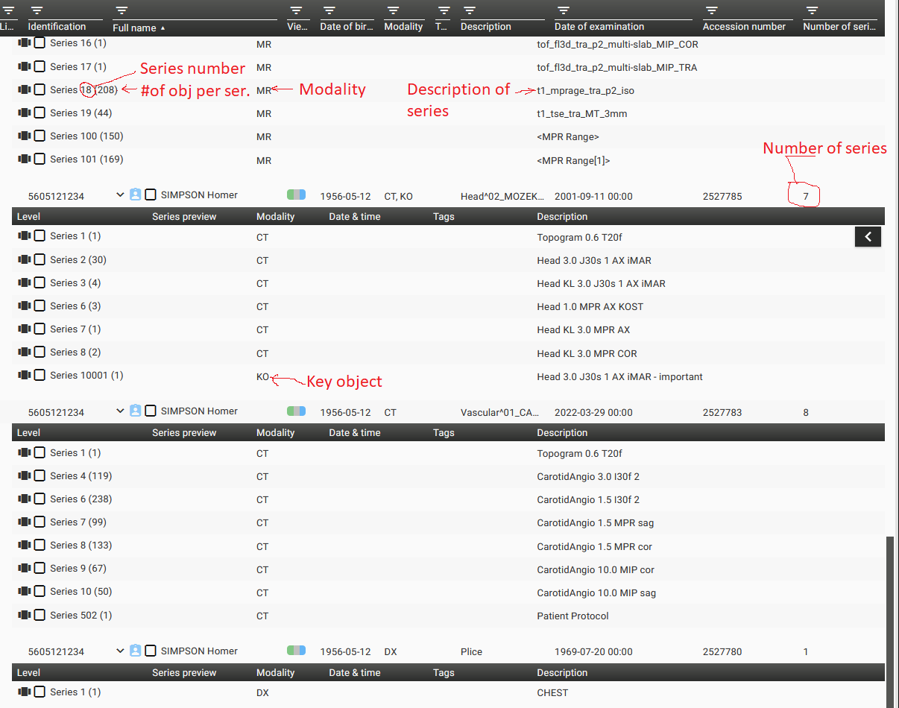

Schematic overview of DICOM imaging study structure:

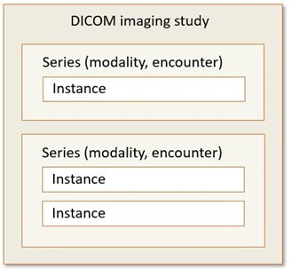

### Article 11: Terminology

There is no specific support information.

### Article *12: Controlled Lists (Valueset Catalogue)*

There is no specific support information.

## Chapter V - Technical Considerations

### Article *13: Technical requirements*

In the following figures, three alternative implementation options are depicted. The options are presented from the perspective of the cross-border exchange of medical imaging reports and imaging studies, for illustrative purposes. However, the options can equally be used at a national level, for example for data sharing between regions. In such cases, no differentiation between data communication networks might be needed, in case the used network provides sufficient bandwidth for sharing imaging studies.

The options are not mutually exclusive and may be combined to ensure the possibility to implement image exchange considering different conditions in different Member States. Further discussion on the choice of a suitable option (or a combination of these) is needed for the implementation in MyHealth@EU.

#### 3.5.1.1. Option A: Transfer of data for viewing in a local system

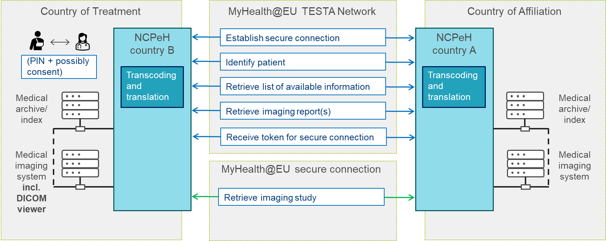

In Option A, both imaging reports and imaging studies are transported from Country A to Country B for their viewing in a local system used by the health professional. The local system could be for example an electronic health record system for imaging reports, and a medical imaging system including a DICOM viewer for imaging studies. The word "local" does not necessarily mean that the system is provided locally on premises, but it could be instead provided for example through a portal-based solution.

The data exchange is initiated through the standard network (TESTA) used for communication between NCPeHs of both countries. All data, with the exception of imaging studies, is transported through this network. However, for imaging studies a separate secure communication channel is established, to ensure sufficient bandwidth. A token for establishing this secure connection is generated between the NCPeHs.

#### Option B: Streaming from Country A

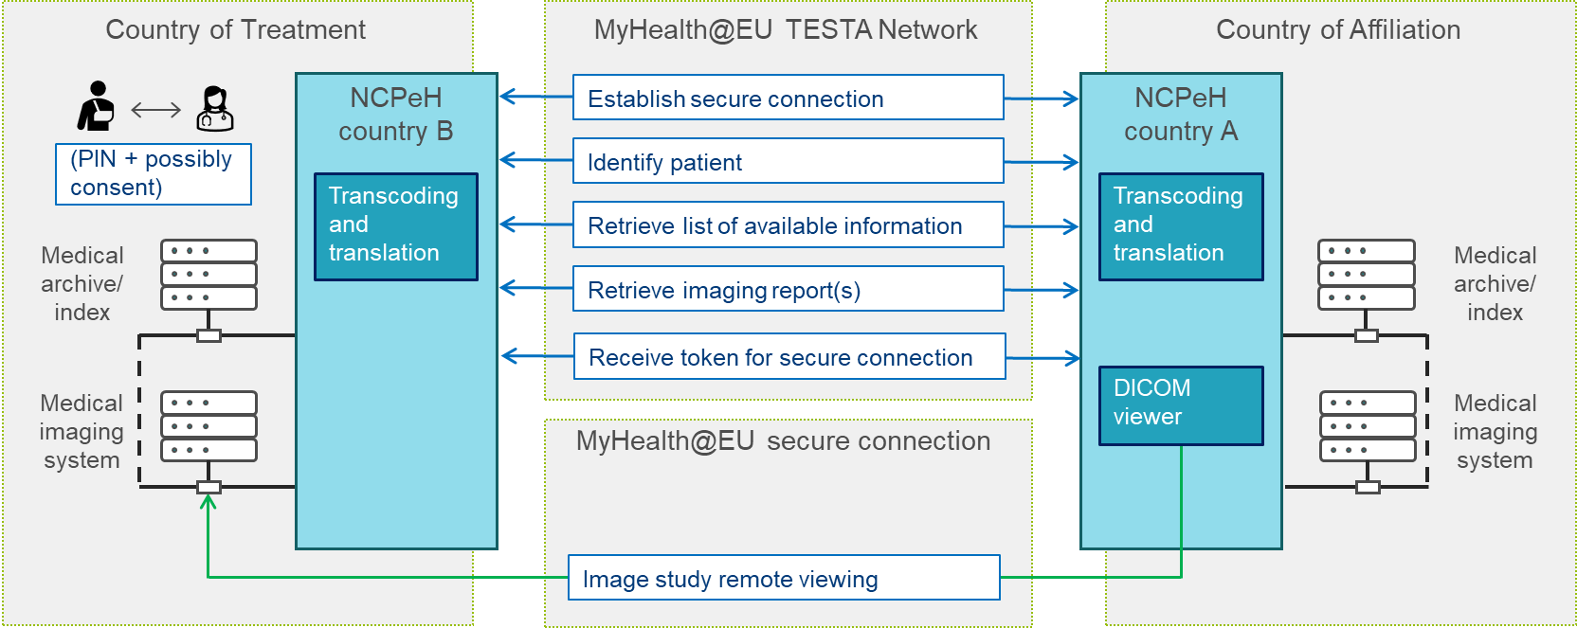

In Option B, imaging reports are transported from Country A to Country B for their viewing in a local system used by the health professional. The local system could be for example an electronic health record system. The word "local" does not necessarily mean that the system is provided locally on-premises, but it could be instead provided for example through a portal-based solution. Imaging studies are however not transported to Country B in their original format. Instead, a DICOM viewer is established at the NCPeH of Country A, and is used by the health professional from Country B. A token enabling the health professional to use the viewer is generated between the NCPeHs.

This option has some limitations that should be considered:

* When calling on different studies, for the same patient a different viewer may be used thus forcing the health professional to adapt to a multiplicity of different viewer user interfaces.
* Securing and authenticating the health professional requesting to view the study across diverse medical imaging systems may impose security and privacy challenges in a cross-border context.
* The user interface offered in Country A language (or in English) might not be well understood by a health professional in Country B.

#### Option C: Streaming between endpoints

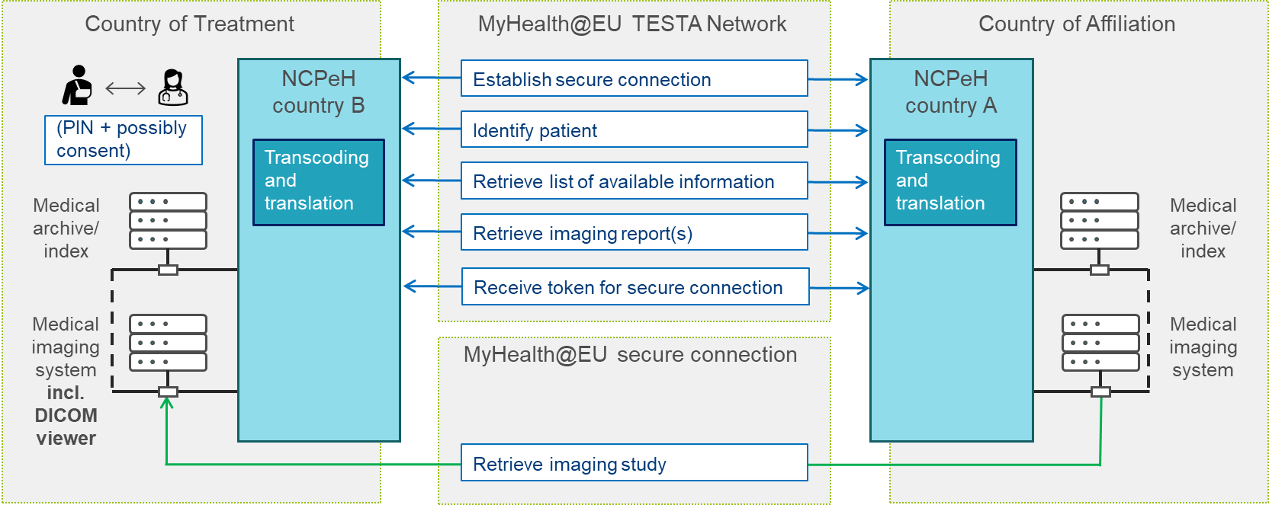

Option C is similar to Option A, with the difference that imaging studies do not pass through the NCPeH of Country A. The rest of the information (medical imaging reports, metadata on imaging studies) is provided through the NCPeH-to-NCPeH communication. For the imaging studies, URLs for their retrieval from the national infrastructure of Country A are provided as part of the metadata on imaging studies.

### Article *14: Security*

There is no specific support information.

### Article *15: Testing and audit*

There is no specific support information.

# DATA SETS

The data sets indicated in the following tables are considered relevant for patient safety and the provision of an adequate level of care both at the cross-border and national levels.

It is up to each implementation project to decide on the conformity and cardinality (i.e. data elements required or optional and the number of repetitions), unless specifically stated.

Implementation projects need to make a final decision on mandatory and/or required (null allowed) elements.

Health insurance and payment information are included in the dataset as an option to support any use case scenarios where this information may play an important role.

Note: some of the code systems or value sets are indicated using the SNOMED CT Expression Constraint Language (ECL) notation.

## Medical imaging report data set

### Medical imaging report header

| **Field** | | **Field description** | **Preferred Code System** |
| --- | --- | --- | --- |
| A.1 Report header data elements | | | |
| A.1.1 Identification of the patient/subject | | | |
| A.1.1.1 | Family name/surname | The family name/surname/last name of the patient. This field can contain more than one element or multiple fields could be present. |  |
| A.1.1.2 | Given name | The given name/first name of the patient (also known as a forename or first name). This field can contain more than one element. |  |
| A.1.1.3 | Date of birth | The date of birth of the patient [ISO TS 22220]. As the age of the patient might be important for the correct interpretation of the test result values, a complete date of birth should be provided. | Complete date, without time, following the ISO 8601 |
| A.1.1.4 | Personal identifier | An identifier of the patient that is unique within a defined scope. Example: Example: National ID (citizen card / eID), health number, passport, etc. Multiple identifiers could be provided. |  |
| A.1.1.5 | Gender | This field must contain a recognised valid value for "administrative gender". | HL7 Administrative Gender |
| A.1.1.6 | Communication language | Language or languages that a patient can communicate |  |
| A.1.2 Patient/subject related contact information | | | |
| A.1.2.1 | Address | Mailing and home or office addresses. The addresses are always sequences of address parts (e.g., street address line, country, ZIP code, city) even if postal address formats may vary depending on the country. An address may or may not include a specific use code; if this attribute is not present it is assumed to be the default address useful for any purpose. | ISO 3166 |
| A.1.2.2 | Telecom | Telecommunication contact information (addresses) associated with a person. Multiple telecommunication addresses might be provided. |  |
| A.1.3 Health insurance and payment information | | | |
| A.1.3.1 | Health insurance information | Health insurance information is not always required, however, in some jurisdictions, the insurance number is also used as the patient identifier. It is necessary not just for identification but also forms access to funding for care. |  |
| A.1.3.1.1 | Health insurance provider code | Unique health insurance company identification code. |  |
| A.1.3.1.2 | Health insurance provider name | The full, official name of the healthcare insurance provider. |  |
| A.1.3.1.3 | Health insurance policy number | Number or code under which the insured person is registered at the insurance provider. |  |
| A.1.4 Information recipient (intended recipient or recipients of the report, additional recipients might be identified by the ordering party, e.g., GP, another specialist), if applicable | | | |
| A.1.4.1 | Recipient identifier | The health professional identification number. Either an internal identifier assigned by a healthcare provider institution or (preferably) a national health professional ID such as the license or registration number. In case when the recipient is not a health professional, e.g., a patient, an appropriate personal identifier should be used. |  |
| A.1.4.2 | Recipient name | Person name. |  |
| A.1.4.3 | Recipient organisation | The healthcare provider organisation information. |  |
| A.1.4.4 | Address | Mailing and home or office addresses. The addresses are always sequences of address parts (e.g., street address line, country, ZIP code, city) even if postal address formats may vary depending on the country. An address may or may not include a specific use code; if this attribute is not present it is assumed to be the default address useful for any purpose. |  |
| A.1.4.5 | Country | Country of the recipient. | ISO 3166 |
| A.1.4.6 | Telecom | Telecommunication contact information (addresses) associated to a person. Multiple telecommunication addresses might be provided. |  |
| A.1.5 Author (by whom the image report or a subset of its results was authored) | | | |
| A.1.5.1 | Author identifier | The health professional or authoring device identification number. Either an internal identifier assigned by a healthcare provider institution or (preferably) a national health professional ID such as the license or registration number. |  |
| A.1.5.2 | Author name | Person or device name. |  |
| A.1.5.3 | Author organisation | The healthcare provider organisation information. |  |
| A.1.5.4 | Authoring date and time | Date and time the document was last modified. |  |
| A.1.6 Legal authenticator (The person taking responsibility for the medical content of the document) | | | |
| A.1.6.1 | Legal authenticator identifier | The health professional identification number. Either an internal identifier assigned by a healthcare provider institution or (preferably) a national health professional ID such as the license or registration number. |  |
| A.1.6.2 | Legal authenticator name | Person name. |  |
| A.1.6.3 | Legal authenticator organisation | The healthcare provider organisation information. |  |
| A.1.6.4 | Authentication date and time | Date and time the document was authorised. | ISO 8601 |
| A.1.7 Result validator (compare with lab result report) | | | |
| A.1.7.1 | Result validator identifier | The health professional identification number. Either an internal identifier assign by a healthcare provider institution or (preferably) a national health professional ID such as the license or registration number. |  |
| A.1.7.2 | Result validator name | Person name. |  |
| A.1.7.3 | Result validator organisation | The healthcare provider organisation information. |  |
| A.1.7.4 | Validation date and time | Date and time when the document was validated. | ISO 8601 |
| A.1.8 Document metadata | | | |
| A.1.8.0 | Document Id | Unique identifier of the document |  |
| A.1.8.1 | Document type | A coded type of the document. Fixed value "Diagnostic Imaging report" | LOINC |
| A.1.8.2 | Document status | The status of the imaging result report. E.g., preliminary, final. | hl7:DiagnosticReportStatus |
| A.1.8.3 | Report date and time | Date and time of the result report creation. | ISO 8601 |
| A.1.8.4 | Document title | Document title, e.g., "Diagnostic Imaging Report" |  |
| A.1.8.5 | Study type | Type (or types) of the imaging study performed.  This element is relevant for the interactive selection of the available studies. | LOINC  SNOMED CT |
| A.1.8.6 | Report custodian | Organization that is in charge of maintaining the image report. | ISO 8601 |
| A.1.8.7 | Confidentiality | Level of confidentiality of the document. Implicit value is normal. | hl7:Confidentiality |
| A.1.8.8 | Language | Language in which the document is written. | ISO 639 |
| A.1.8.9 | Version | Version of the document. |  |
| A.1.8.10 | Study Instance UID | Unique global identifier that identifies an imaging study upon which the imaging report is based.  An identifier that links an imaging study to an imaging report.  This element is relevant for the interactive selection of the available studies. | OID |
| A.1.8.11 | Accession number | This is an identifier, at the local level, which usually identifies an imaging procedure request, and links it to imaging study(ies) and related imaging report(s). |  |

### Medical imaging report body

| **Field** | | **Field description** | **Preferred Code System** |
| --- | --- | --- | --- |
| **A.2  Order information** Note: an Imaging Report could respond to multiple orders. | | | |
| A.2.1 | Order Id | A unique identifier of the imaging study order. |  |
| A.2.2 | Order date and time | Date and time of the order placement. | ISO 8601 |
| A.2.3 | Order placer identifier | The health professional identification number. Either an internal identifier assigned by a healthcare provider institution or (preferably) a national health professional ID such as the license or registration number. |  |
| A.2.4 | Order placer name | Person name. |  |
| A.2.5 | Order placer specialty | Medical specialty of the requester (e.g. Oncology, Neurosurgery, Dermatology, Gastroenterology)  This element is relevant for the interactive selection of the available studies. |  |
| A.2.6 | Order placer contact details | Contact details of order placer (address and telecom details). |  |
| A.2.7 | Order placer organisation | Order placer organisation information. |  |
| **A.3 Order reason** Note: an Imaging Report could respond to multiple reasons | | | |
| A.3.1 | Reason | Description of a clinical condition indicating why imaging examination was ordered. The reason could be expressed in coded or textual form. The reason represents the primary condition or finding leading up to a request for an imaging investigation. Example: "Cough lasting for 3 months" | SNOMED CT |
| A.3.2 | Problem / diagnosis / condition | Health conditions affecting the health of the patient are important to be known for a health professional in relation to the imaging encounter. Clinical conditions of the subject are relevant for the interpretation of the results. | ICD-10 (ICD-11 when available) SNOMED CT Orphacode |
| A.3.3 | Clinical question | Specification of clinical question (goal of the investigation) to be answered by the imaging investigation. |  |
| **A.4 Specimen information** Note: a specimen (not attached to a body) can be used for diagnostic, forensic and medical research purposes. | | | |
| A.4.1 | Specimen identifier | An identifier of the specimen which is unique within in a defined scope. Example: identifier assigned by ordering system. Multiple identifiers can be used. |  |
| A.4.2 | Material | Specimen material (e.g. "Specimen from breast obtained by biopsy"). | SNOMED CT <123038009 |Specimen (specimen)| |
| A.4.3 | Collection period | Collection date time or period. | ISO 8601 |
| A.4.4 | Anatomic location | Anatomic location (body location, laterality) where the material is collected (e.g. "Elbow, left"). | SNOMED CT ICD-O-3 |
| A.4.5 | Morphology | Morphological abnormalities of the anatomical location where the material is taken, for example wound, ulcer. | SNOMED CT |
| A.4.6 | Source Device | If the material is not collected directly from the patient but comes from a patient-related object, e.g. a catheter | SNOMED CT |
| EMDN |
| A.4.7 | Collection procedure/method | If relevant for the results, the method of obtaining the specimen. | SNOMED CT |
| A.4.8 | Received date | Date and time that the material is handed over at imaging department or workplace performing imaging study. | ISO 8601 |
| **A.5 Examination Report** | | | |
| ***A.5.1*** | ***Imaging procedure description*** Note: this part records the technical details of the procedures and may include information about protocol, imaging device, anatomical location, performer, place, datetime of performance, radiation dose. | | |
| A.5.1.1 | Modality | Imaging modality (or modalities) used during imaging investigation (DICOM CID029).  This element is relevant for the interactive selection of the available studies. | DICOM Modality |
| A.5.1.2 | Procedure date | Date and time of the procedure or interval of its performance. | ISO 8601 |
| A.5.1.3 | Procedure text | Detail textual description of the procedure. |  |
| A.5.1.4 | Procedure code | Code representing the procedure. | SNOMED CT |
| A.5.1.5 | Procedure name | Full name of the procedure according to the used procedure coding standard. |  |
| **A.5.1.6** | **Anatomical focus (Part of the body focused during the procedure)** | | |
| A.5.1.6.1 | Body location | Localisation on/in the body (part of the body focused during the procedure).  The element could be repeated to provide information at multiple levels (bigger body location, smaller body location).  This element is relevant for the interactive selection of the available studies. | SNOMED CT <442083009 |Anatomical or acquired body structure (body structure)| ICD-O-3 |
| A.5.1.6.2 | Laterality | Body side of the body location, if needed to distinguish from a similar location on the other side of the body. | SNOMED CT, <182353008 |Side (qualifier value)| |
| A.5.1.6 | Device ID | Normalised identifier of the device instance such as UDI according to REGULATION (EU) 2017/745. |  |
| A.5.1.7 | Performer | Identifies the performer of the procedure. |  |
| A.5.1.7.1 | Performer Id | Performer identifier unique within a given context (namespace). Either an internal identifier assign by a healthcare provider institution or (preferably) a national health professional ID such as the license or registration number. |  |
| A.5.1.7.2 | Performer Name | Person name. |  |
| A.5.1.7.3 | Performer Organisation | The healthcare provider organisation information. |  |
| ***A.5.2*** | ***Medication (Medication section includes information about medication administered (contrast, sedation, stress agents), etc.)*** | | |
| A.5.2.1 | Brand name | Brand name of biological medicinal product or when justified by the health professional (ref. Commission Directive 2012/52/EU) |  |
| A.5.2.2 | Active ingredient list | Substance that alone or in combination with one or more other ingredients produces the intended activity of a medicinal product. Example: "paracetamol" | ATC* (IDMP identifier, when available) |
| A.5.2.3 | Strength | The content of the active ingredient expressed quantifiably per dosage unit, per unit of volume or per unit of weight, according to the pharmaceutical dosage form. Example: 500 mg per tablet | UCUM, EDQM Standard Terms |
| A.5.2.4 | Pharmaceutical dose form | The form in which a pharmaceutical product is presented in the medicinal product package (e.g. tablet, syrup) | EDQM Standard Terms |
| A.5.2.5 | Route of administration | Path by which the pharmaceutical product is taken into or makes contact with the body. | EDQM Standard Terms |
| A.5.2.6 | Date and time | Date and time of medication |  |
| ***A.5.3*** | ***Adverse reaction (Adverse reactions manifested during imaging investigation.)*** | | |
| A.5.3.1 | Allergy description | Textual description of the allergy or intolerance |  |
| A.5.3.2 | Type of propensity | This element describes whether this condition refers to an allergy, non-allergy intolerance, or unknown class of intolerance (not known to be allergy or intolerance) | SNOMED CT GPS |
| A.5.3.3 | Allergy manifestation | Description of the clinical manifestation of the allergic reaction. Example: anaphylactic shock, angioedema (the clinical manifestation also gives information about the severity of the observed reaction) | SNOMED CT GPS |
| A.5.3.4 | Severity | Severity of the clinical manifestation of the allergic reaction. | SNOMED CT GPS |
| A.5.3.5 | Criticality | Potential risk for future life-threatening adverse reactions when exposed to a substance known to cause an adverse reaction. | SNOMED CT GPS |
| A.5.3.6 | Onset date | Date of the observation of the reaction | ISO 8601 |
| A.5.3.7 | Certainty | Assertion about the certainty associated with a propensity, or potential risk, of a reaction to the identified substance. Diagnostic and/or clinical evidence of the condition. | SNOMED CT GPS [Consider HL7 CodeSystem HL7.TERMINOLOGY\AllergyIntolerance Verification Status - FHIR v4.0.1 ] |
| A.5.3.8 | Agent or Allergen | A specific allergen or other agent/substance (drug, food, chemical agent, etc.)  to which the patient has an adverse reaction propensity. | SNOMED CT GPS (for non-drug allergy) or ATC* (for drug allergy) (IDMP, when available) |
| ***A.5.4*** | ***Results***  Note: The results summarise the findings and observations by the health professional following image study. Note: this part includes textual as well as structured results or findings of the imaging investigation). | | |
| A.5.4.1 | Date | Date and time of the observation | ISO 8601 |
| A.5.4.2 | Result text | Comments and narrative representation of the observation results and findings. |  |
| A.5.4.3 | Observation details (report could contain multiple observations, e.g. dimensions, density etc.) | | |
| A.5.4.3.1 | Observation code | Code representing the observation. | SNOMED CT |
| A.5.4.3.2 | Observation name | Full name of the observation according to the used observation coding standard. |  |
| A.5.4.3.3 | Observation method | Observation method (measurement principle) to obtain the result. | SNOMED CT |
| A.5.4.3.4 | Observation result | Results of the observation including text, numeric and coded results of the measurement and measurement uncertainty. The content of the observation result will vary according to the type of observation. Examples: diameter, density, and number of nodes. | SNOMED CT (for ordinal or nominal scale results and result interpretation) UCUM (for units) |
| ***A.5.5*** | ***Conclusion*** A concise and clinically contextualised summary including interpretation/impression of the diagnostic report | | |
| A.5.5.1 | Impression | Narrative description of the clinical conclusion (impression). |  |
| A.5.5.2 | Coded conclusions (Coded clinical conclusions (impressions) expressed as conditions or observations). | | |
| A.5.5.2.1 | Condition or finding | Condition or finding from imaging investigation. | ICD-10* SNOMED CT GPS Orphacode |
| A.5.5.2.2 | Staging or grading | Assessment of the condition expressed using common staging or grading (typically TNM but also other) or coded observations (Bi-Rads, Li-Rads etc.). | TNM Bi-Rads Li-Rads etc. |
| **A.5.6** | **Recommendation** (This section may include recommendations for additional imaging tests or other actions) | | |
| A.5.6.1 | Description | Narrative description of the recommended activities including additional tests, medication etc. |  |
| A.5.6.2 | Care plan | Complex and structured information about recommended goals, activities and objectives in the form of one or more formal care plans. Consider FHIR Care plan resource. |  |
| **A.6 Key images associated with this report** | | | |
| A.6.1 | View | The name of the imaging view e.g. Lateral or Antero-posterior (AP). |  |
| A.6.2 | Body location | Anatomic location (body location, laterality) where the material is collected, e.g. Elbow, left | SNOMED CT ICD-O-3 |
| A.6.3 | Media type | Classification of media as image, video, or audio. | hl7:media-type |
| A.6.4 | Modality | The type of acquisition equipment/process.  This element is relevant for the interactive selection of the available studies. | DICOM Modality |
| A.6.5 | Device | The device used to perform an imaging study | SNOMED CT EMDN |
| A.6.6 | Format | Height, width, and number of frames of the image in pixels (photo/video). | UCUM |
| A.6.7 | Duration | The duration of the recording in seconds - for audio and video. | UCUM |
| A.6.8 | Performer | Identifies the performer of the imaging acquisition process. Performer may include: performer identifier, performer name, performer type, performer medical speciality, performer organisation, and performer contact details. |  |
| A.6.9 | Comment | A comment about the image. Typically, this is used to provide an explanation for why the image is included, or to draw the viewer's attention to important features. |  |
| A.6.10 | Content | Actual Media - reference or data. Consider FHIR Attachment resource. |  |
| **A.7 Comparison study** | | | |
| A.7.1 | Comparison Study | Documentation (reference) of a prior Imaging Report to which the current images were compared. |  |
| **A.8 Presented form** | | | |
| A.8.1 | Attachment | Entire report as issued. Rich text representation of the entire result as issued by the diagnostic service. Multiple formats are allowed but they SHALL be semantically equivalent. |  |

## Imaging study DICOM Metadata data set

The data set defines the contents of the imaging study metadata.

|  |  |  |  |
| --- | --- | --- | --- |
| **B.1 Imaging study DICOM Metadata** | | | |
| B.1.1 | Study instance UID | Globally unique identifier of the study. If one or more series elements are present in the Imaging Study, then there shall be one DICOM Study UID identifier.  This element is relevant for the interactive selection of the available studies. |  |
| B.1.2 | Number of series | Number of Series in the Study. This value given may be larger than the number of series elements this Resource contains due to resource availability, security, or other factors. This element should be present if any series elements are present.  This element is relevant for the interactive selection of the available studies. |  |
| B.1.3 | Number of instances | Number of  Service-Object Pairs (SOP) Instances in Study. This value given may be larger than the number of instance elements this resource contains due to resource availability, security, or other factors. This element should be present if any instance elements are present.  This element is relevant for the interactive selection of the available studies. |  |
| B.1.4 | Description | The Imaging Manager description of the study. Institution-generated description or classification of the Study (component) performed.  This element is relevant for the interactive selection of the available studies. |  |
| B.1.5 | Study custodian | Organization name, address, and contact information. |  |
| B.1.6 | Study endpoint | An endpoint describes the technical details of a location that can be connected to for the delivery/retrieval of information. Sufficient information is required to ensure that a connection can be made securely, and appropriate data transmitted as defined by the endpoint owner. These may be locally hosted services, regional services, or national services. |  |
| ***B.1.7*** | ***Series*** | | |
| B.1.7.1 | Series information | Imaging series information including the number of instances in series, acquisition modality, series number and UID, instances, device and other DICOM series details. |  |
| B.1.7.2 | Series endpoint | An endpoint describes the technical details of a location that can be connected to for the delivery/retrieval of information. Sufficient information is required to ensure that a connection can be made securely, and appropriate data transmitted as defined by the endpoint owner. These may be locally hosted services, regional services, or national services. |  |
| ***B.1.7.3*** | ***Instances in the series*** | | |
| B.1.7.3.1 | Instance title | The description of the instance. |  |
| B.1.7.3.2 | Instance data | DICOM data describing instance such as sopClass, instance number, UID. |  |
| B.1.7.3.3 | Radiation dose information | Kerma area product (KAP), Total KAP, Kerma at the end of tube (dental X-ray), Thickness of breast for the calculation of Average absorbed breast dose. |  |
| B.1.7.4 | Phase | Study phase, e.g., without contrast, arterial phase, venous phase, delayed phase. Only some types of studies have phases. | SNOMED CT |

# REFERENCES AND EXAMPLES

DICOM standard: <https://www.dicomstandard.org/>

DICOM Part 20: <https://dicom.nema.org/dicom/2013/output/chtml/part20/sect_A.3.html>

FHIR standard: <https://hl7.org/fhir/>